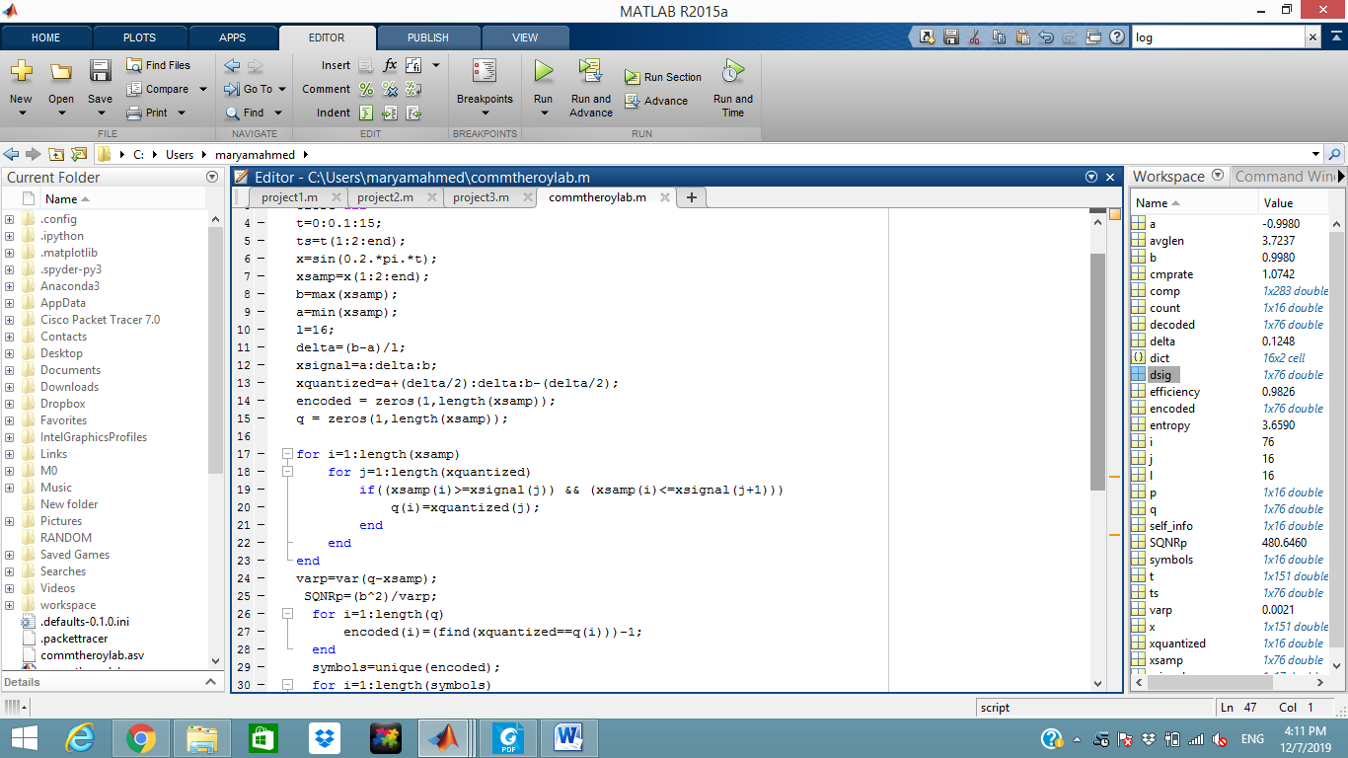

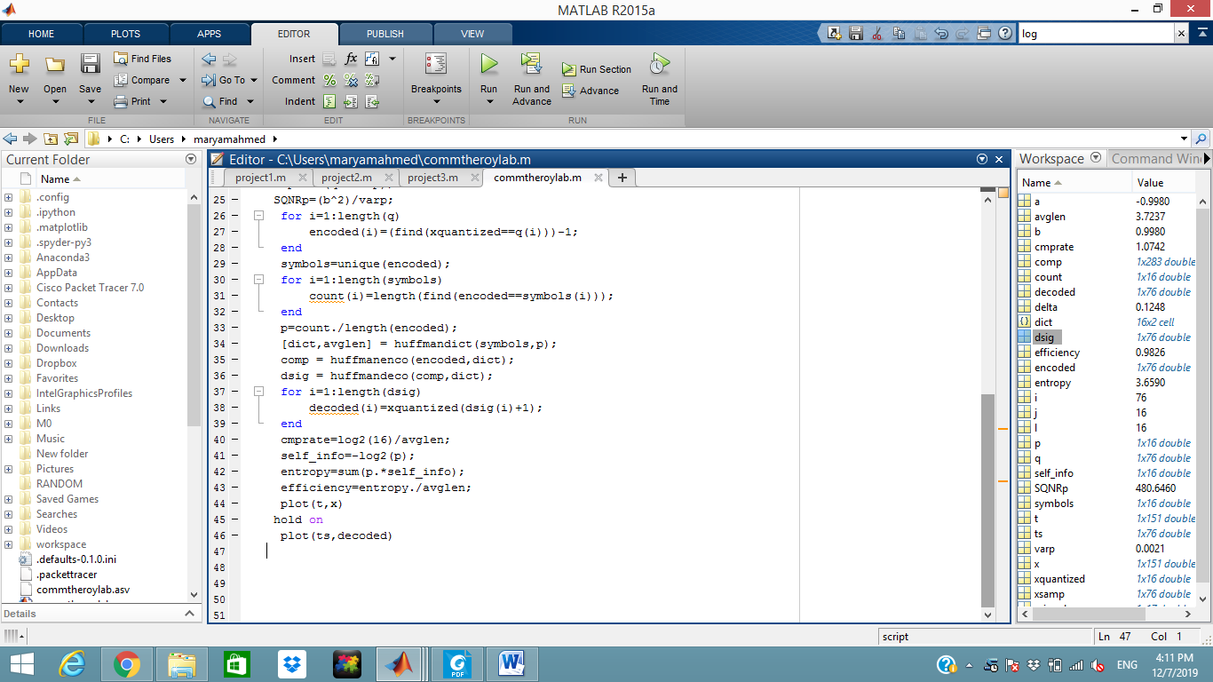

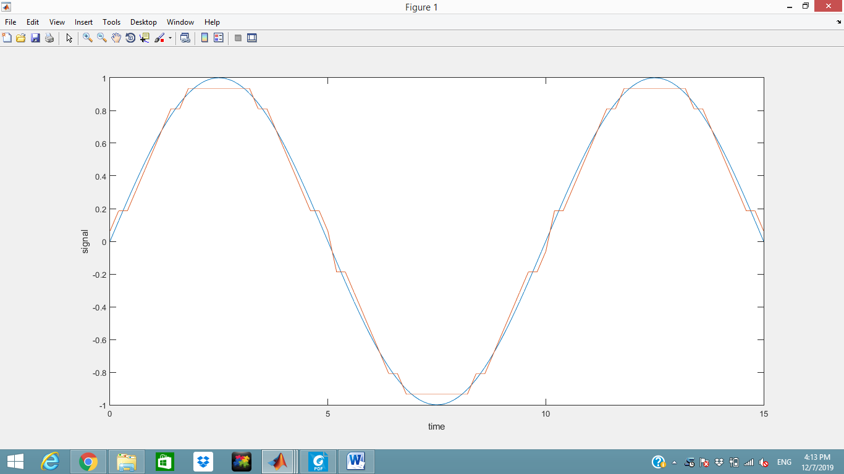

**SQNR=4.806**

**Efficiency=0.982**

**Compression rate=1.074**

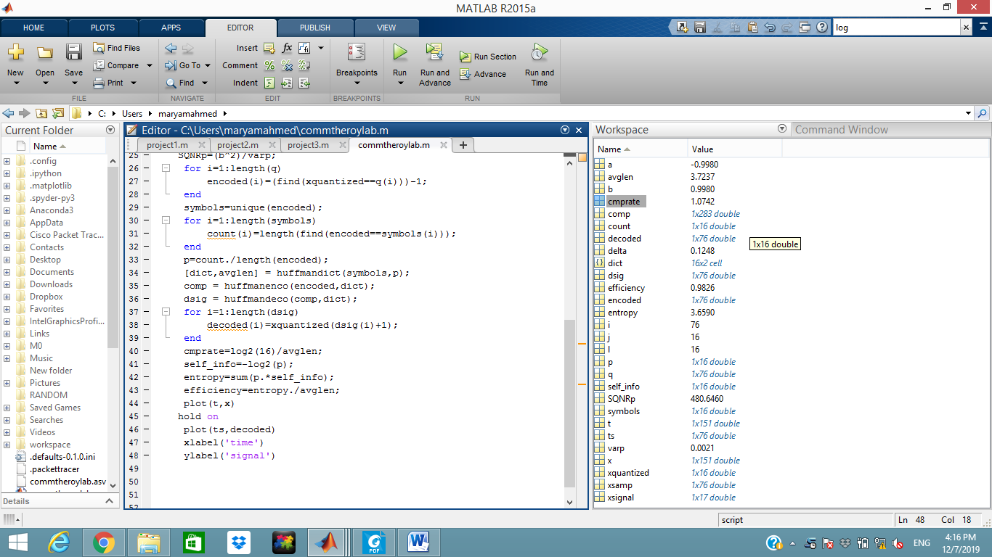

**The difference between the input and the output is due to sampling the original signal so some information in the input is not transmitted .**

**To enhance the output we should increase the sampling rate by decreasing the sampling time so less information is lost in transmission from the original input signal.**